12.AIM:-To implement UML diagrams for Foreign Trading System..

1.SEQUENCE DIAGRAM:

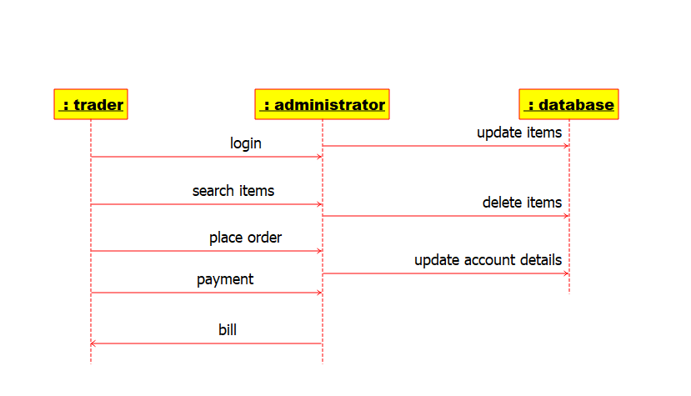

2.ACTIVITY DIAGRAM:-

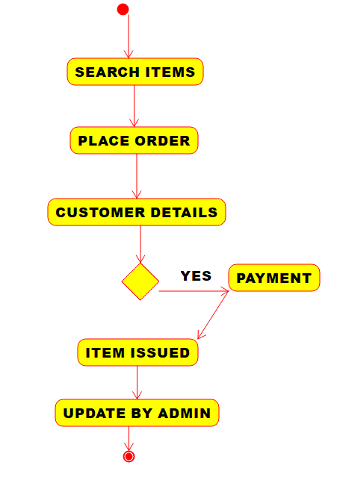

3.COMPONENT DIAGRAM:-

